

***Project Proposal***
LEARNING MANAGEMENT SYSTEM :

Submitted by
Zubia Hameed
(F22BINFT1E02139)
7th semester 1E
Submitted to
Ma'am Sara Fareed

Department of Information Technology
The Islamia University of Bahawalpur

Final Year Project Proposal Guide

TABLE OF CONTENTS
FINAL PROJECT PROPOSAL GUIDE 3
- INTRODUCTION 3
  - PROJECT TITLE 3
  - PROJECT OVERVIEW STATEMENT 4
  - PROJECT OVERVIEW STATEMENT TEMPLATE…………………………………………………………………………..5
  - PROJECT GOALS & OBJECTIVES 6
  - HIGH LEVEL SYSTEM COMPONENTS………………………………………………………………………………………8
  - APPLICATION ARCHITECTURE……………………………………………………………………………………………...9
  - GANTT CHART…………………………………………………………………………………………………………………10
  - HARDWARE & SOFTWARE SPECIFICATION…………………………………………………………………………….10
  - TOOLS AND TECHONOLOGIES USED WITH REASONING……………………………………………………………..11
Final Project Proposal Guide

Introduction

Everything nowadays is moving forward and merging themselves with technologies to accelerate their performance in the market efficiently. Same way, the education sectors are also engaging with different advance technologies for their management. Learning Management System is playing a very major and important role in the field of education to manage things more professionally in less time without headache. This development journey encircles the creation of a dynamic, user-friendly platform that not only centralizes educational resources but also fosters engagement, assessment, and continuous improvement among them.

Project Title

LMS stands for “Learning Management System”. The name itself describes that it is related to learning & education, which means that it will provide the features that how the delivery of knowledge/education will be manage, delivered, maintain & the all-other possible aspects. The title "LMS" becomes a symbol of innovation, adaptability, and the pursuit of excellence in education. It signifies your commitment to empowering learners and instructors in an increasingly digital world. "LMS" ensures to be more than just an acronym, it represents a gateway to modern, efficient, and accessible education to everyone just in a very easy way anywhere in the whole world.

Project Overview Statement

In our educational landscape, the need for an advanced Learning Management System (LMS) has become important. Our proposal, "Learning Management System" addresses this importance by introducing a cutting-edge LMS tailored to meet the dynamic needs of modern educational institutions. Our LMS streamlines administrative tasks, ensuring teachers & faculty can focus on teaching, not paperwork. This project focus on innovation, drawing on my team's extensive experience in educational technology. With a focus on efficiency, personalization, and innovation, our project seeks to provide teachers and students alike with a cutting-edge platform that not only simplifies administrative processes but also enhances the overall educational experience. The LMS will serve as a comprehensive platform for educational institutions, instructors, and students to interact, collaborate, and engage in a virtual learning environment without facing any difficulties. It will feature user-friendly interfaces, content management capabilities, and different tools to foster dynamic and interactive learning experiences. The LMS will prioritize intuitive navigation and user experience, ensuring that both teachers and students can easily access and utilize its features. The LMS will incorporate data analytics capabilities, enabling faculty to gain insights into student performance and engagement, thereby facilitating data-driven instructional improvements. This component collects and analyzes data on user activities, course engagement, and learning outcomes. It generates reports and insights to assist instructors and administrators in making data-driven decisions.
  - Project Overview Statement Template:
Name | Registration# | EmailAddress | Signature
Hammad Hassan | Bsf2005092 | Bsf2005092@ue.edu.pk
Kashan Aslam | Bsf1903834 | Bsf1903834@ue.edu.pk

Project Title: Learning Management System
Group Leader: Hammad Hassan
ProjectMembers:
Project Goal:
To develop a comprehensive Learning Management System (LMS) that enhances the educational experience by providing a user-friendly, adaptable, and feature-rich platform for educational institutions, instructors, and students.
Objectives:
 | Sr.#
 | 1 | User-friendly environment
 | 2 | User authentication & User authorization
 | 3 | Course Management
 | 4 | Attendance of both teacher and student
 | 5 | Scalability
 | 6 | Feedback System
Project Success criteria:
Scope, Timeline, Cost, Client Goals, Deliverable, Resource Capacity, Risk Management, Documenttation
Assumptions, Risks and Obstacles: Technical Expertise, Hardware & Software Compatibility, User Training, Data Accuracy, Technical Risks, Continuously Changes, User training, Data security, competition, Data migration challenges, external factors
Organization Address (if any): University of Education Multan, Lahore Campus
Type of project: Research Development
Target End users: Students, teachers, administrative faculty of educational sector
Development Technology: Php Object Oriented Programming Structured Database Designing in html & css
Platform: Visual Studio Xamp
Suggested Project Supervisor:
Approved By:
Date:

  - Project Goals & Objectives:

In this section, we outline the goals and specific objectives of our LMS project. It's important to differentiate between goals, which set the broader context and purpose, and objectives, which define measurable outcomes and guide our project's activities.

Project Goals:

The goals represent the high-level aspirations of our LMS project, setting the stage for what we aim to achieve. They provide the overarching vision and context for our efforts.

Enhance Educational Experience:
- Create an LMS that significantly enhances the overall educational experience for students, instructors, and administrators.
- Foster engagement, efficiency, and improved learning outcomes.

User-Friendly Interface:
- Develop an intuitive and user-friendly interface that facilitates easy navigation and accessibility.

Comprehensive Course Management:

- Implement robust course management features to empower instructors in creating, managing, and delivering courses effectively.

Project Objectives:

The objectives represent the specific, measurable outcomes we aim to accomplish throughout the project. They will serve as the foundation for our project activities and the basis for evaluating our project's success.

Compile a Comprehensive List of Objectives:

- Prepare a detailed list of project objectives, ensuring they are specific, measurable, and aligned with our overarching goals.

Conduct User-Centered Design Research:

- Engage in user-centered design research to gather feedback from potential LMS users, including students, instructors, and administrators.
Develop Prototypes for User Testing:

- Create functional prototypes of key LMS components to conduct user testing and gather usability insights.

Implement User-Friendly Interface:

- Develop an intuitive user interface with a focus on ease of navigation and accessibility, measured by user satisfaction surveys.

Build Course Management Features:

- Implement course creation, content management, and assessment tools for instructors, tracked by system usage statistics.

Perform User Acceptance Testing:

- Conduct thorough user acceptance testing to ensure the LMS meets user requirements and expectations.

Collect User Feedback and Iterate:

- Continuously gather user feedback throughout development and make iterative improvements based on user input.

Ensure Scalability and Reliability:

- Assess and optimize the LMS for scalability and reliability to accommodate a growing user base.

High-level system components

This section provides an overview of the primary functional units and high-level system components that will constitute our Learning Management System (LMS) project. These components are essential for the seamless operation of the LMS, ensuring that it fulfills its mission of enhancing the educational experience.

- Inputs: Inputs to the LMS include user data (registration information, profiles), course content (documents, multimedia), user interactions (discussion posts, assessment submissions), and system configurations.

- Outputs: Outputs encompass the display of course materials, user-generated content, assessment results, communication messages, and reports. Outputs are presented to users through the LMS interface.

- Processes: Processes involve the core functionalities of the LMS, including user authentication, content storage and retrieval, communication management, assessment processing, and data analytics.

- Stored Data: Stored data encompasses user profiles, course content, assessment records, communication archives, and analytical data. Secure and efficient data management is vital for the LMS's functionality.

- Reporting and Analytics: This component collects and analyzes data on user activities, course engagement, and learning outcomes. It generates reports and insights to assist instructors and administrators in making data-driven decisions.

Application Architecture

The application architecture of our Learning Management System (LMS) defines the overall organizational structure of the system, including its components and how they interact. The chosen architecture plays a pivotal role in ensuring the LMS's efficiency and scalability. Our LMS will adopt a three-tier architecture, which separates the system into three distinct layers: presentation, logic, and data. This architecture promotes modularity, maintainability, and scalability, allowing for efficient management of educational content and user interactions.

- Presentation Layer (Tier 1):

  - The presentation layer is the user interface (UI) of the LMS, where users interact with the system. It includes web pages, mobile app interfaces, and user experiences.

  - User-friendly and responsive design ensures accessibility across various devices and browsers.

  - Interfaces and user interactions are designed to provide an intuitive and engaging learning experience.

- Logic Layer (Tier 2):

  - The logic layer contains the business logic and application logic of the LMS. It serves as the intermediary between the presentation layer and the data layer.

  - User requests and actions from the presentation layer are processed here, and appropriate responses are generated.

- Data Layer (Tier 3):

  - The data layer stores and manages all data used by the LMS. It includes databases and storage systems responsible for storing user profiles, course content, assessment records, communication archives, and analytical data.

  - Data management is designed for efficiency, security, and scalability to ensure that the LMS can handle large volumes of educational content and user data.

Gantt chart

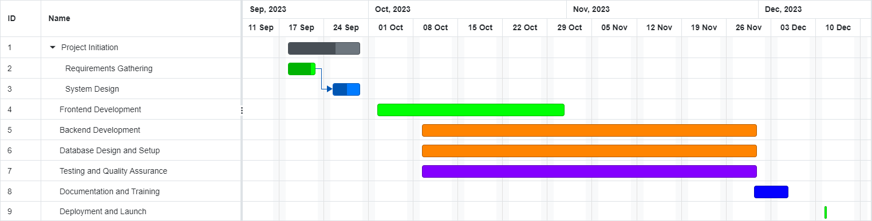

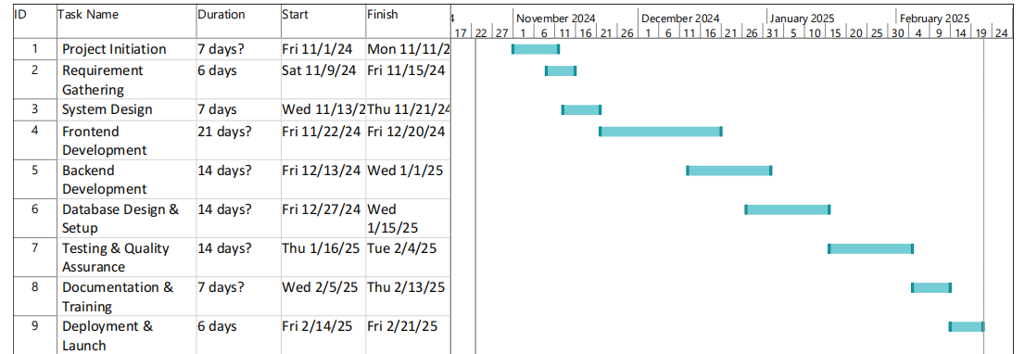

Hardware and Software Specification

The hardware and software specifications for Learning Management System (LMS) project will depend on various factors, including the technology stack you choose, the expected user load, and the scalability requirements. Below is a general outline of hardware and software specifications for your LMS:

Hardware Specifications:

  - Computer System/Hosting Server

  - Network/Internet

Software Specifications:

  - Operating System

  - Web Browser

  - Database Management System

  - Development Environment

Tools and technologies used with reasoning

The application tools, which are to be used on front and backend of the system to be developed, are as listed below:

Development Tools:

- Integrated Development Environment (IDE):

  - Visual Studio Code: A popular, free, and open-source code editor that supports multiple programming languages.

- Database Management:

  - MariaDB: A visual database design and administration tool for MySQL databases.

- Backend Frameworks:

  - Laravel: A high-level Php web framework known for its security features and rapid development capabilities.

- Frontend Frameworks and Libraries:

  - React: A JavaScript library for building user interfaces.

  - Bootstrap: A progressive JavaScript framework for building interactive web interfaces.

